1. **Introduction to business problem**

Company Four is an upstream provider of automation and control products and services, to process based industries. They cater to an international clientele, with a strategic focus on the Asia Pacific Region that include oil and gas, Petrochemicals, Beverage and wastewater treatment. Their core products offerings include:

i) Process automation systems

ii) Measurement & instrumentation devices

iii) High-performance automation controller solution

iv) telemetry systems with 24/7 customer service and

v) software solution to close the loop for optimal control and decision-making in manufacturing, industry, infrastructure, data centres, buildings, and homes.

The main goal of the Company Four is to increase the market share in Asia Pacific. The scope of this document’s study is to analyze from the product perspective, to do a high level exploratory study on the markets our various products are successful in, the products that we might want to discontinue or innovate upon, or to find areas where our product support may be less than ideal.

Revenue and Orders are the lifeblood of any company, and one key area that is a key ingredient of Customer Orders would be our Products, so the aim is to find out

* Which markets are using which products
* Which products are the hot sellers, and which ones need improvement
* Product properties such as seasonality of product demand

With the aim of suggesting solutions or to conduct a more thorough investigation at a later stage

1. **Data Modelling**

The choice of dashboard tool used is Tableau, with some fixes done in Excel before being loaded into Tableau

The data was sourced from our teammate’s firm and firm names, product names were anonymized

Data Definition ( In the excel file package attached below)



**Data Quality**

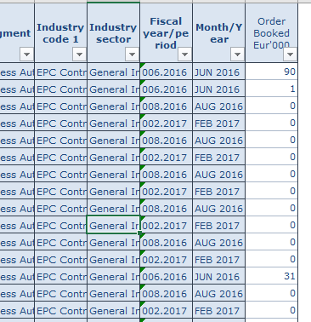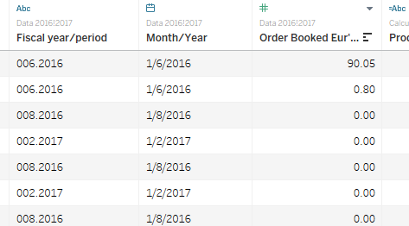

Fiscal year/period and month/year not in standard date format that they can read, so an extra column was created, month year by slicing the fiscal year/period , removing the first zero, to become 06.2016, and then adding 01, for the first day of the month, and replacing dots, . , with slashes, /, to obtain a valid standard date range which can be used

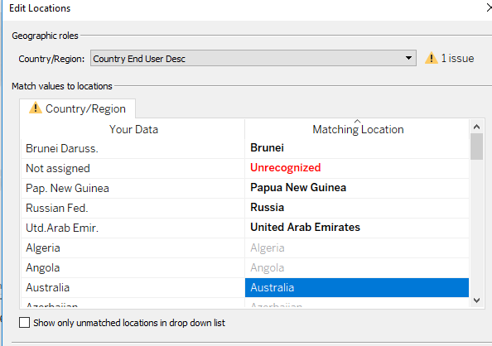

Also by checking the locations of the country end user, or the ultimate buyer, some of the values were not recognized by tableau, for geo-location, so they were fixed manually, as shown above

Furthermore, the data came in a locked excel file format .XLSX , which was extracted using R, and saved into a CSV for better compatibility, as some issues was faced accessing the files initially , and was unable to create a base table from the excel book, which turned out from a Google search to be a limitation of the product

For this exercise there was only one excel sheet of data used, so that created only one table in tableau, not requiring any joins. In total the dataset contains 91564 rows of data, with 28 columns, for the duration of years Jan 2016 until Dec 2017, so the data model is as shown below

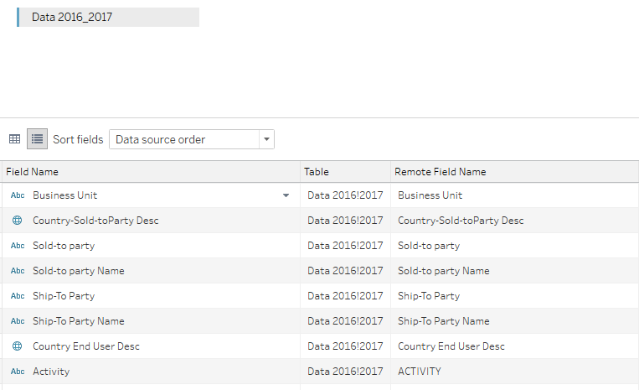

1. **Overall Dashboard layout**

The dashboard comes in two parts, one pane for the executives to get a high level view on the distribution of products around key markets, and the 2nd pane for managers to be able to drill down and have further discussions on which products would be beneficial to promote, to innovate upon, or to discontinue or write off due to asset impairment, to support their decision making process

As the company does not hold inventory, aka they practice Just in time inventory management, one of the aims of the dashboard would be to identify product lines which are likely more efficient for the firm to hold

Executive Director pane

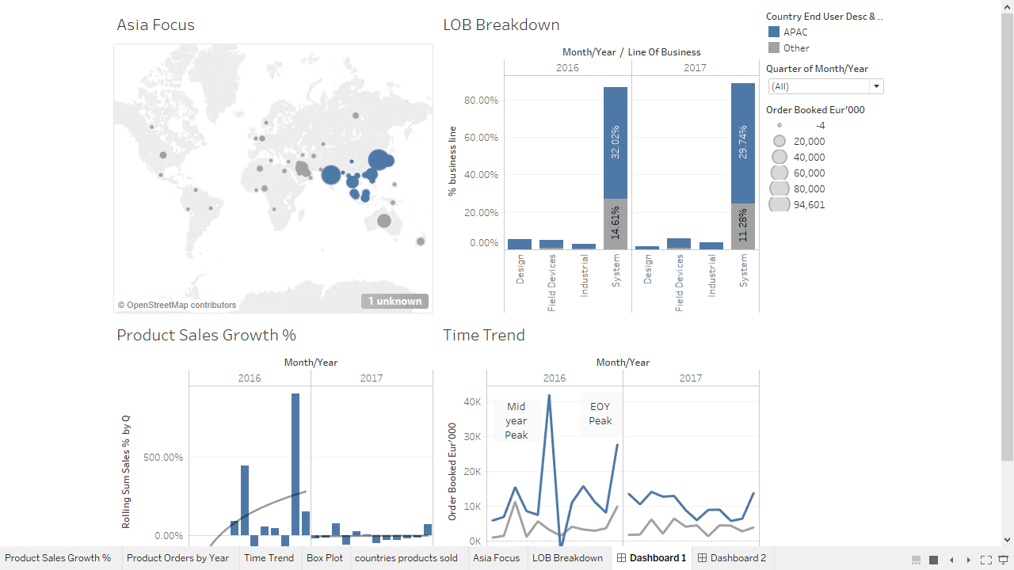

The main selector in this case would be the top left, ‘**Asia Focus’** , where it shows a global high level view of the current orders per market in the 2 year dataset, 2016-2017, where the blue circles are part of the APAC grouping, and grey circles are the rest of the markets, some high level insights that can be gleaned from this would be that the firms biggest market segment is likely to be APAC, Australia and Middle East, based on the End user Domiciles. It is segmentation between APAC and other zones

In the APAC segment, China segment looks like it has opportunities for product growth, and India, Korea and Japan are likely strong markets

It is useful to note that when orders are cancelled, what the firm does is input a negative value to the database with the product, based on client’s needs, therefore one limitation to the analysis is that these are all summed Order Values, as the median or average of the values would be affected by the negative values

The graph on the bottom right, ‘Product Sales Growth %’, is based on rolling quartiles, meaning that it compares the current month’s summed order value with the previous quarter’s , with the below formula



Where ZN() replaces a null with a Zero, and Lookup returns the earlier values, so the entire calculation returns a value that acts like an index on Quintiles’ to see the rate of change on a rolling month basis

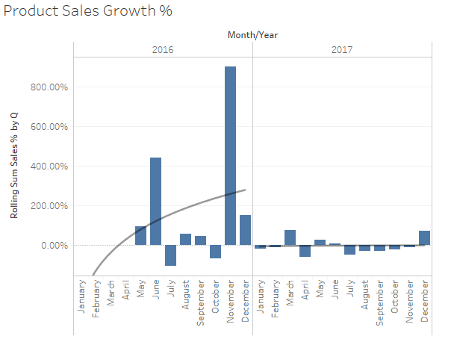

We can see two big spikes in june and December for 2016, which, on checking with the company sources, corresponds to the usual order booking period, but in 2017, the change month on month seems linear and is likely not growing very much

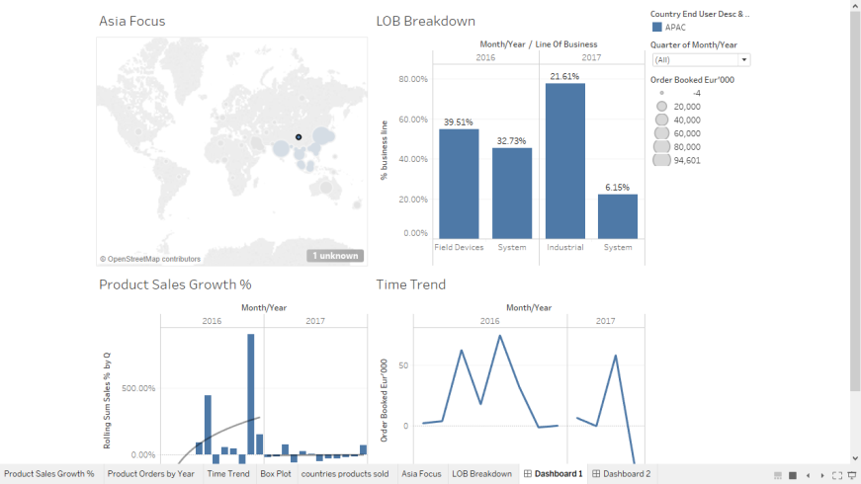

If the executive chooses to select China, the dashboard will show the major Lines of Business for the market, and the time trend shows the orders booked throughout the year in 2016 and 2017, so that the executives have more information to make better decisions on acquiring or removing business units to lower operating costs to the firm.

For Time Trend, the spikes likely represent order booking seasons, which make sense if a high volume is ordered in the previous month, and the client over ordered, with surplus ordered into the next month, and so next month is cancelled ,aka negative periods, like the drop in the last quarter of 2017, likely show an increase in order cancellation, however as such data is not publicly available, more analysis needs to be conducted on this area, this is useful for the directors as it affects working capital turnover

Managerial View pane

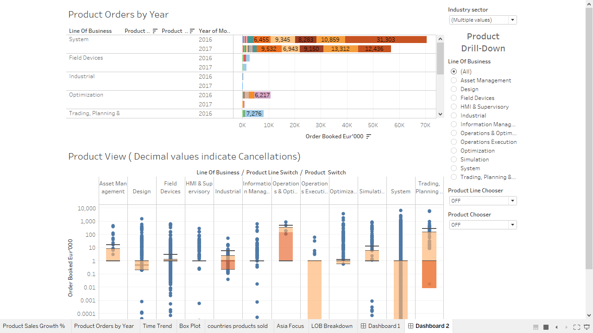

Hierarchical chooser

This view is aimed at Managers, who are more interested in knowing which products under the lines of business and products lines are more profitable which are less profitable.

Products have a hierarchical grouping, where the executives look at the top level,

1. Line of Business , followed by
2. Product Line, and finally
3. Product Name

So in tableau, a hierarchical grouping was created

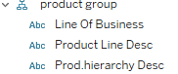

Where the firm has 12 unique lines of businesses ( LOB), and product lines ( hundreds) spanning from each line of businesses, and finally individual components sold were described in ‘Prod hierarchy Desc’

But this was parent child relation was not able to be sorted directly from the dashboard, so a parameter was created for product line and product, like below, with two values

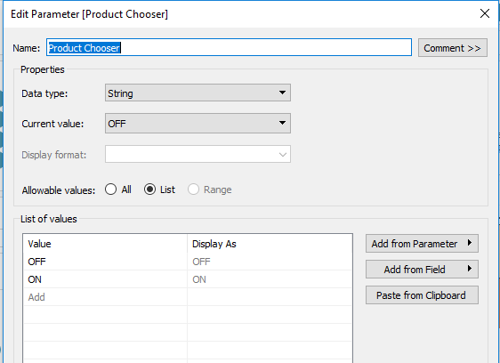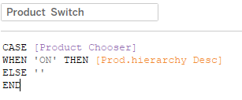

With the parameter to configure, a switch was added, with a case statement so that the managers can filter on the various product lines to find profitable or non-profitable lines at a glance

Product Box Plot when both switches are off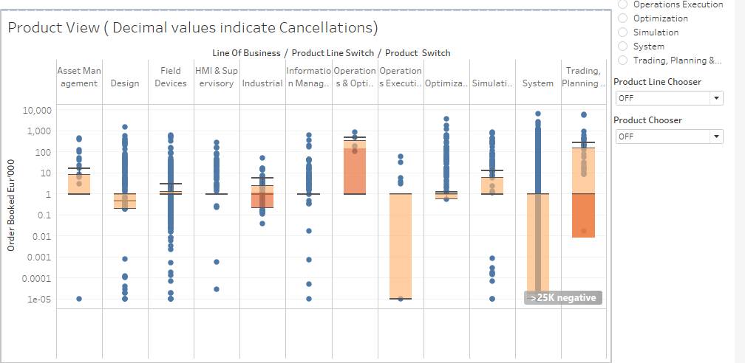f

Product Box Plot when switches are on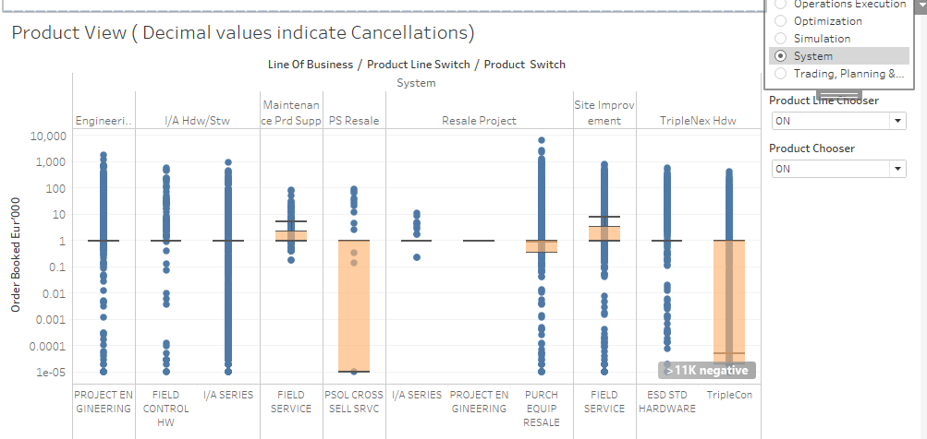

Above, is an example of a study by the manager, for example in China, the line of business of ‘Systems’ was a large contributor to product orders, so the manager can drill down, each blue dot is an individual order, and where the orange rectangle is above 1, ( as the y-axis is log scaled) indicates a profitable product line as the median and inter quartile range are positive, whereas for a product like TripleCon, the inter quartile range is less than one, and as negative values become decimals when log is applied, indicates that there are quite a number of cancellations for this product, and could deep dive or reach out to clients to find out the reasons behind this observation. Also the line between the light and dark orange is where the median value is, the lines above the quartile range indicates 1.5 times the inter quartile range

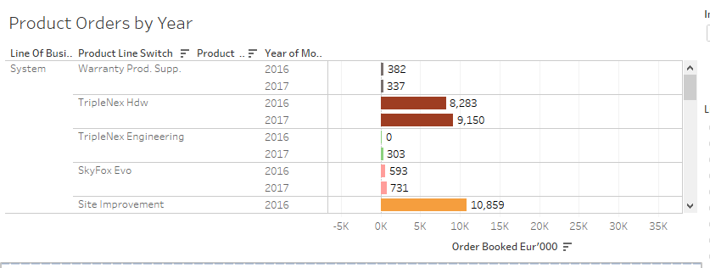

The same filters also work on product by orders per year, to find profitable lines

1. **Limitations of data**
2. As the current process for cancellation involves creating a record with negative values with the same product as the sold record’s product, it is hard to tell if the record is an actual cancellation or is due to a human error, as the two values are very hard to be reconciled, so setting threshold benchmarks in the future could be problematic, and as we are unable to tell the implication of this process, the impact is hard to estimate, and could possible lead to false trend analysis

* T0 solve this problem, we propose creating another column with a binary flag to indicate if the record was cancelled instead of the current system of negative values

1. Also due to having limited data on the actual products and not having access to product experts, for example for thriplecon, with negative Inter Quartile Range, it is hard to tell the exact reason why , and would require further studies which would incur additional cost and labour hours
2. **Conclusion**

It appears that the business trend is such that, for June and December orders tend to peak, however for 2017, from the Executive view, it looks like a gradual decline, which would be a cause of concern, a red flag for the business across all the lines of business, as it would result in lower operating profits

As it is hard to tell if the order volumes have a data issue, the analysis from this report should be checked with business divisions for agreement before the relevant decisions are made, and should only be used as a guide, until the negative system is changed